Міністерство освіти і науки України

**Прикарпатський національний університет**

**імені В.Стефаника**

*Факультет математики та інформатики*

*Кафедра інформаційних технологій*

*Людинно-машинна взаємодія*

Лабораторна робота № 9

Тема: Створення проекту «Калькулятор»

*Варіант 2*

Виконав: ***Гук Д.П.***

Група ІПЗ-31

Дата:2 грудня 2023 р.

Викладач: Пікуляк М.В.

Івано-Франківськ – 2023

**Мета роботи:**

Створити проект «Калькулятор» за допомогою ICP “Qt-Creator”

**Завдання для виконання :**

Створити калькулятор за допомогою ICP “Qt-Creator”

**Текст скриптів і зображення діалогових вікон QtCreator з виконаним завданням :**

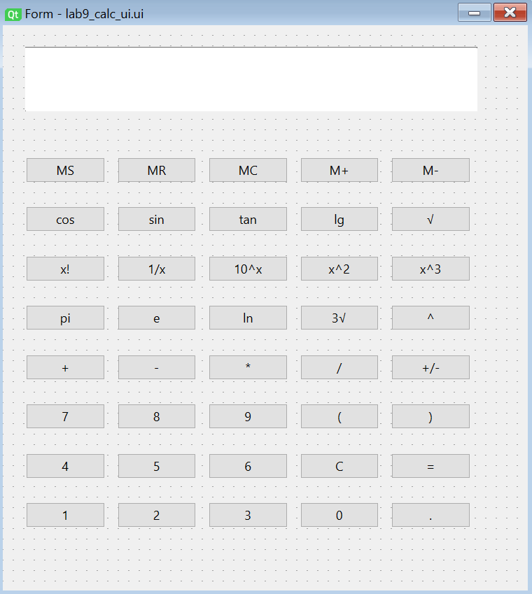

**Клас CalculatorLogic :**

class CalculatorLogic:  
 def __init__(self, form):  
 self.form = form  
 self.setup_buttons()  
 self.memory = []  
 self.pending_operation = None  
 self.display_text = ''  
 self.result_shown = False  
  
  
 def setup_buttons(self):  
 self.form.pushButton.clicked.connect(self.memory_store)  
 self.form.pushButton_17.clicked.connect(self.memory_recall)  
 self.form.pushButton_25.clicked.connect(self.memory_clear)  
 self.form.pushButton_31.clicked.connect(self.memory_add)  
 self.form.pushButton_26.clicked.connect(self.memory_pop)  
  
 self.form.pushButton_16.clicked.connect(self.addition)  
 self.form.pushButton_22.clicked.connect(self.division)  
 self.form.pushButton_19.clicked.connect(self.subtraction)  
 self.form.pushButton_28.clicked.connect(self.multiplication)  
  
 self.form.pushButton_2.clicked.connect(self.cos)  
 self.form.pushButton_15.clicked.connect(self.sin)  
 self.form.pushButton_21.clicked.connect(self.tan)  
  
 self.form.pushButton_37.clicked.connect(self.factorial)  
 self.form.pushButton_4.clicked.connect(self.power)  
 self.form.pushButton_24.clicked.connect(self.square_root)  
 self.form.pushButton_32.clicked.connect(self.three_root)  
 self.form.pushButton_40.clicked.connect(self.power_of_ten)  
 self.form.pushButton_38.clicked.connect(self.power_two)  
 self.form.pushButton_39.clicked.connect(self.power_three)  
 self.form.pushButton_36.clicked.connect(self.power_minus_one)  
 self.form.pushButton_30.clicked.connect(self.logarithm_10)  
 self.form.pushButton_27.clicked.connect(self.logarithm_nat)  
  
 self.form.pushButton_5.clicked.connect(lambda: self.add_to_display('7'))  
 self.form.pushButton_6.clicked.connect(lambda: self.add_to_display('4'))  
 self.form.pushButton_7.clicked.connect(lambda: self.add_to_display('1'))  
 self.form.pushButton_18.clicked.connect(lambda: self.add_to_display('8'))  
 self.form.pushButton_11.clicked.connect(lambda: self.add_to_display('5'))  
 self.form.pushButton_9.clicked.connect(lambda: self.add_to_display('2'))  
 self.form.pushButton_23.clicked.connect(lambda: self.add_to_display('9'))  
 self.form.pushButton_10.clicked.connect(lambda: self.add_to_display('6'))  
 self.form.pushButton_34.clicked.connect(lambda: self.add_to_display('3'))  
 self.form.pushButton_35.clicked.connect(lambda: self.add_to_display('0'))  
 self.form.pushButton_3.clicked.connect(lambda: self.add_to_display('3.14'))  
 self.form.pushButton_20.clicked.connect(lambda: self.add_to_display('2.72'))  
 self.form.pushButton_13.clicked.connect(lambda: self.add_to_display('('))  
 self.form.pushButton_41.clicked.connect(lambda: self.add_to_display(')'))  
 self.form.pushButton_29.clicked.connect(self.change_sign)  
 self.form.pushButton_33.clicked.connect(self.decimal_pressed)  
  
  
 self.form.pushButton_8.clicked.connect(self.calculate_result)  
 self.form.pushButton_14.clicked.connect(self.clear_display)  
  
  
  
 def change_sign(self):  
 try:  
 value = float(self.form.lineEdit.text())  
 value *= -1  
 self.form.lineEdit.setText(str(value))  
 except ValueError:  
 self.form.lineEdit.setText("Error")  
  
 def decimal_pressed(self):  
 current_text = self.form.lineEdit.text()  
 if '.' not in current_text:  
 self.form.lineEdit.setText(current_text + '.')  
  
 def memory_pop(self):  
 index = self.get_memory_index()  
 try:  
 if index is not None and 0 <= index < len(self.memory):  
 self.form.lineEdit.setText("")  
 self.memory_index = index  
 self.form.lineEdit.setPlaceholderText("Enter value to subtract")  
 self.form.pushButton_26.clicked.disconnect()  
 self.form.pushButton_26.clicked.connect(lambda: self.memory_store_value('pop'))  
 else:  
 self.form.lineEdit.setText("Invalid memory index")  
 except ValueError:  
 self.form.lineEdit.setText("Error")  
  
 def memory_add(self):  
 index = self.get_memory_index()  
 try:  
 if index is not None and 0 <= index < len(self.memory):  
 self.form.lineEdit.setText("")  
 self.memory_index = index  
 self.form.lineEdit.setPlaceholderText("Enter value to add")  
 self.form.pushButton_31.clicked.disconnect()  
 self.form.pushButton_31.clicked.connect(lambda: self.memory_store_value('add'))  
 else:  
 self.form.lineEdit.setText("Invalid memory index")  
 except ValueError:  
 self.form.lineEdit.setText("Error")  
  
 def get_memory_index(self):  
 try:  
 index = int(self.form.lineEdit.text())  
 return index  
 except ValueError:  
 return None  
  
 def memory_store_value(self, operation):  
 try:  
 value = float(self.form.lineEdit.text())  
 if hasattr(self, 'memory_index'):  
 index = self.memory_index  
 if operation == 'add':  
 self.memory[index] += value  
 delattr(self, 'memory_index')  
 self.form.lineEdit.setPlaceholderText("")  
 self.form.pushButton_31.clicked.disconnect()  
 self.form.pushButton_31.clicked.connect(self.memory_add)  
 self.form.lineEdit.setText("")  
 elif operation == 'pop':  
 self.memory[index] -= value  
 delattr(self, 'memory_index')  
 self.form.lineEdit.setPlaceholderText("")  
 self.form.pushButton_26.clicked.disconnect()  
 self.form.pushButton_26.clicked.connect(self.memory_pop)  
 self.form.lineEdit.setText("")  
 else:  
 self.form.lineEdit.setText("Please select a memory index first")  
 except ValueError:  
 self.form.lineEdit.setText("Error")  
  
 def memory_store(self):  
 input_text = self.form.lineEdit.text()  
 if input_text:  
 try:  
 self.memory.append(float(input_text))  
 self.form.lineEdit.setText("")  
 except ValueError:  
 self.form.lineEdit.setText("Invalid input for memory")  
 else:  
 self.form.lineEdit.setText("")  
  
 def memory_recall(self):  
 try:  
 index = int(self.form.lineEdit.text())  
 if 0 <= index < len(self.memory):  
 recalled_value = self.memory[index]  
 self.form.lineEdit.setText(str(recalled_value))  
 elif len(self.memory) == 0:  
 self.form.lineEdit.setText("Memory is empty")  
 else:  
 self.form.lineEdit.setText("Index out of range")  
 except ValueError:  
 self.form.lineEdit.setText("Invalid index")  
  
 def memory_clear(self):  
 self.memory.clear()  
  
  
  
 def cos(self):  
 try:  
 value = float(self.form.lineEdit.text())  
 result = math.cos(math.radians(value))  
 self.form.lineEdit.setText(str(result))  
 except ValueError:  
 self.form.lineEdit.setText("Error")  
  
  
  
 def sin(self):  
 try:  
 value = float(self.form.lineEdit.text())  
 result = math.sin(math.radians(value))  
 self.form.lineEdit.setText(str(result))  
 except ValueError:  
 self.form.lineEdit.setText("Error")  
  
 def tan(self):  
 try:  
 value = float(self.form.lineEdit.text())  
 result = math.tan(math.radians(value))  
 self.form.lineEdit.setText(str(result))  
 except ValueError:  
 self.form.lineEdit.setText("Error")  
  
 def logarithm_10(self):  
 try:  
 value = float(self.form.lineEdit.text())  
 result = math.log10(value)  
 self.form.lineEdit.setText(str(result))  
 except ValueError:  
 self.form.lineEdit.setText("Error")  
  
 def logarithm_nat(self):  
 try:  
 value = float(self.form.lineEdit.text())  
 result = math.log(value)  
 self.form.lineEdit.setText(str(result))  
 except ValueError:  
 self.form.lineEdit.setText("Error")  
  
 def factorial(self):  
 try:  
 value = int(self.form.lineEdit.text())  
 result = math.factorial(value)  
 self.form.lineEdit.setText(str(result))  
 except ValueError:  
 self.form.lineEdit.setText("Error")  
 except OverflowError:  
 self.form.lineEdit.setText("Result too large")  
  
 def addition(self):  
 try:  
 current_text = self.form.lineEdit.text()  
 if '+' not in current_text:  
 self.form.lineEdit.setText(current_text + ' + ')  
 else:  
 parts = current_text.split(' + ')  
 if len(parts) == 2:  
 num1, num2 = map(float, parts)  
 result = num1 + num2  
 self.form.lineEdit.setText(str(result))  
 self.result_shown = True  
 except Exception as e:  
 self.form.lineEdit.setText("Error")  
  
 def division(self):  
 try:  
 current_text = self.form.lineEdit.text()  
 if '/' not in current_text:  
 self.form.lineEdit.setText(current_text + ' / ')  
 else:  
 parts = current_text.split(' / ')  
 if len(parts) == 2:  
 num1, num2 = map(float, parts)  
 result = num1 / num2  
 self.form.lineEdit.setText(str(result))  
 self.result_shown = True  
 except Exception as e:  
 self.form.lineEdit.setText("Error")  
  
 def subtraction(self):  
 try:  
 current_text = self.form.lineEdit.text()  
 if '-' not in current_text:  
 self.form.lineEdit.setText(current_text + ' - ')  
 else:  
 parts = current_text.split(' - ')  
 if len(parts) == 2:  
 num1, num2 = map(float, parts)  
 result = num1 - num2  
 self.form.lineEdit.setText(str(result))  
 self.result_shown = True  
 except Exception as e:  
 self.form.lineEdit.setText("Error")  
  
 def modulus(self):  
 try:  
 current_text = self.form.lineEdit.text()  
 if '%' not in current_text:  
 self.form.lineEdit.setText(current_text + ' % ')  
 else:  
 parts = current_text.split(' % ')  
 if len(parts) == 2:  
 num1, num2 = map(float, parts)  
 result = num1 % num2  
 self.form.lineEdit.setText(str(result))  
 self.result_shown = True  
 except Exception as e:  
 self.form.lineEdit.setText("Error")  
  
 def multiplication(self):  
 try:  
 current_text = self.form.lineEdit.text()  
 if '*' not in current_text:  
 self.form.lineEdit.setText(current_text + ' * ')  
 else:  
 parts = current_text.split(' * ')  
 if len(parts) == 2:  
 num1, num2 = map(float, parts)  
 result = num1 * num2  
 self.form.lineEdit.setText(str(result))  
 self.result_shown = True  
 except Exception as e:  
 self.form.lineEdit.setText("Error")  
  
 def power(self):  
 try:  
 current_text = self.form.lineEdit.text()  
 if '**' not in current_text:  
 self.form.lineEdit.setText(current_text + ' ** ')  
 else:  
 parts = current_text.split(' ** ')  
 if len(parts) == 2:  
 num1, num2 = map(float, parts)  
 result = num1 ** num2  
 self.form.lineEdit.setText(str(result))  
 self.result_shown = True  
 except Exception as e:  
 self.form.lineEdit.setText("Error")  
 def square_root(self):  
 try:  
 value = float(self.form.lineEdit.text())  
 result = math.sqrt(value)  
 self.form.lineEdit.setText(str(result))  
 except ValueError:  
 self.form.lineEdit.setText("Error")  
  
 def three_root(self):  
 try:  
 value = float(self.form.lineEdit.text())  
 result = math.pow(value, (1/3))  
 self.form.lineEdit.setText(str(result))  
 except ValueError:  
 self.form.lineEdit.setText("Error")  
  
 def power_two(self):  
 try:  
 value = float(self.form.lineEdit.text())  
 result = math.pow(value, 2)  
 self.form.lineEdit.setText(str(result))  
 except ValueError:  
 self.form.lineEdit.setText("Error")  
  
 def power_minus_one(self):  
 try:  
 value = float(self.form.lineEdit.text())  
 result = 1 / value  
 self.form.lineEdit.setText(str(result))  
 except ValueError:  
 self.form.lineEdit.setText("Error")  
  
 def power_three(self):  
 try:  
 value = float(self.form.lineEdit.text())  
 result = math.pow(value, 3)  
 self.form.lineEdit.setText(str(result))  
 except ValueError:  
 self.form.lineEdit.setText("Error")  
  
 def power_of_ten(self):  
 try:  
 value = float(self.form.lineEdit.text())  
 result = math.pow(10, value)  
 self.form.lineEdit.setText(str(result))  
 except ValueError:  
 self.form.lineEdit.setText("Error")  
  
 def add_to_display(self, value):  
 current_text = self.form.lineEdit.text()  
 if self.result_shown:  
 self.result_shown = False  
 self.display_text = ''  
 self.form.lineEdit.setText(current_text + value)  
  
 def clear_display(self):  
 self.form.lineEdit.setText("")  
 self.display_text = ''  
 self.result_shown = False  
  
 def calculate_result(self):  
 try:  
 expression = self.form.lineEdit.text()  
 result = eval(expression)  
 self.form.lineEdit.setText(str(result))  
 self.result_shown = True  
 except Exception as e:  
 self.form.lineEdit.setText("Error")

**Клас Ui_Form :**

class Ui_Form(object):  
 def setupUi(self, Form):  
 Form.setObjectName("Calculator")  
 Form.resize(470, 500)  
 self.lineEdit = QtWidgets.QLineEdit(parent=Form)  
 self.lineEdit.setGeometry(QtCore.QRect(22, 22, 422, 61))  
 self.lineEdit.setObjectName("lineEdit")  
 lineEdit_font = self.lineEdit.font()  
 lineEdit_font.setPointSize(16)  
 self.lineEdit.setFont(lineEdit_font)  
 self.pushButton = QtWidgets.QPushButton(parent=Form)  
 self.pushButton.setGeometry(QtCore.QRect(22, 126, 75, 24))  
 self.pushButton.setObjectName("pushButton")  
 self.pushButton_2 = QtWidgets.QPushButton(parent=Form)  
 self.pushButton_2.setGeometry(QtCore.QRect(22, 173, 75, 24))  
 self.pushButton_2.setObjectName("pushButton_2")  
 self.pushButton_3 = QtWidgets.QPushButton(parent=Form)  
 self.pushButton_3.setGeometry(QtCore.QRect(22, 267, 75, 24))  
 self.pushButton_3.setObjectName("pushButton_3")  
 self.pushButton_4 = QtWidgets.QPushButton(parent=Form)  
 self.pushButton_4.setGeometry(QtCore.QRect(370, 267, 75, 24))  
 self.pushButton_4.setObjectName("pushButton_4")  
 self.pushButton_5 = QtWidgets.QPushButton(parent=Form)  
 self.pushButton_5.setGeometry(QtCore.QRect(22, 361, 75, 24))  
 self.pushButton_5.setObjectName("pushButton_5")  
 self.pushButton_6 = QtWidgets.QPushButton(parent=Form)  
 self.pushButton_6.setGeometry(QtCore.QRect(22, 408, 75, 24))  
 self.pushButton_6.setObjectName("pushButton_6")  
 self.pushButton_7 = QtWidgets.QPushButton(parent=Form)  
 self.pushButton_7.setGeometry(QtCore.QRect(22, 455, 75, 24))  
 self.pushButton_7.setObjectName("pushButton_7")  
 self.pushButton_8 = QtWidgets.QPushButton(parent=Form)  
 self.pushButton_8.setGeometry(QtCore.QRect(370, 408, 75, 24))  
 self.pushButton_8.setObjectName("pushButton_8")  
 self.pushButton_9 = QtWidgets.QPushButton(parent=Form)  
 self.pushButton_9.setGeometry(QtCore.QRect(109, 455, 75, 24))  
 self.pushButton_9.setObjectName("pushButton_9")  
 self.pushButton_10 = QtWidgets.QPushButton(parent=Form)  
 self.pushButton_10.setGeometry(QtCore.QRect(196, 408, 75, 24))  
 self.pushButton_10.setObjectName("pushButton_10")  
 self.pushButton_11 = QtWidgets.QPushButton(parent=Form)  
 self.pushButton_11.setGeometry(QtCore.QRect(109, 408, 75, 24))  
 self.pushButton_11.setObjectName("pushButton_11")  
 self.pushButton_13 = QtWidgets.QPushButton(parent=Form)  
 self.pushButton_13.setGeometry(QtCore.QRect(283, 361, 75, 24))  
 self.pushButton_13.setObjectName("pushButton_13")  
 self.pushButton_14 = QtWidgets.QPushButton(parent=Form)  
 self.pushButton_14.setGeometry(QtCore.QRect(283, 408, 75, 24))  
 self.pushButton_14.setObjectName("pushButton_14")  
 self.pushButton_15 = QtWidgets.QPushButton(parent=Form)  
 self.pushButton_15.setGeometry(QtCore.QRect(109, 173, 75, 24))  
 self.pushButton_15.setObjectName("pushButton_15")  
 self.pushButton_16 = QtWidgets.QPushButton(parent=Form)  
 self.pushButton_16.setGeometry(QtCore.QRect(22, 314, 75, 24))  
 self.pushButton_16.setObjectName("pushButton_16")  
 self.pushButton_17 = QtWidgets.QPushButton(parent=Form)  
 self.pushButton_17.setGeometry(QtCore.QRect(109, 126, 75, 24))  
 self.pushButton_17.setObjectName("pushButton_17")  
 self.pushButton_18 = QtWidgets.QPushButton(parent=Form)  
 self.pushButton_18.setGeometry(QtCore.QRect(109, 361, 75, 24))  
 self.pushButton_18.setObjectName("pushButton_18")  
 self.pushButton_19 = QtWidgets.QPushButton(parent=Form)  
 self.pushButton_19.setGeometry(QtCore.QRect(109, 314, 75, 24))  
 self.pushButton_19.setObjectName("pushButton_19")  
 self.pushButton_20 = QtWidgets.QPushButton(parent=Form)  
 self.pushButton_20.setGeometry(QtCore.QRect(109, 267, 75, 24))  
 self.pushButton_20.setObjectName("pushButton_20")  
 self.pushButton_21 = QtWidgets.QPushButton(parent=Form)  
 self.pushButton_21.setGeometry(QtCore.QRect(196, 173, 75, 24))  
 self.pushButton_21.setObjectName("pushButton_21")  
 self.pushButton_22 = QtWidgets.QPushButton(parent=Form)  
 self.pushButton_22.setGeometry(QtCore.QRect(283, 314, 75, 24))  
 self.pushButton_22.setObjectName("pushButton_22")  
 self.pushButton_23 = QtWidgets.QPushButton(parent=Form)  
 self.pushButton_23.setGeometry(QtCore.QRect(196, 361, 75, 24))  
 self.pushButton_23.setObjectName("pushButton_23")  
 self.pushButton_24 = QtWidgets.QPushButton(parent=Form)  
 self.pushButton_24.setGeometry(QtCore.QRect(370, 173, 75, 24))  
 self.pushButton_24.setObjectName("pushButton_24")  
 self.pushButton_25 = QtWidgets.QPushButton(parent=Form)  
 self.pushButton_25.setGeometry(QtCore.QRect(196, 126, 75, 24))  
 self.pushButton_25.setObjectName("pushButton_25")  
 self.pushButton_26 = QtWidgets.QPushButton(parent=Form)  
 self.pushButton_26.setGeometry(QtCore.QRect(370, 126, 75, 24))  
 self.pushButton_26.setObjectName("pushButton_26")  
 self.pushButton_27 = QtWidgets.QPushButton(parent=Form)  
 self.pushButton_27.setGeometry(QtCore.QRect(196, 267, 75, 24))  
 self.pushButton_27.setObjectName("pushButton_27")  
 self.pushButton_28 = QtWidgets.QPushButton(parent=Form)  
 self.pushButton_28.setGeometry(QtCore.QRect(196, 314, 75, 24))  
 self.pushButton_28.setObjectName("pushButton_28")  
 self.pushButton_29 = QtWidgets.QPushButton(parent=Form)  
 self.pushButton_29.setGeometry(QtCore.QRect(370, 314, 75, 24))  
 self.pushButton_29.setObjectName("pushButton_29")  
 self.pushButton_30 = QtWidgets.QPushButton(parent=Form)  
 self.pushButton_30.setGeometry(QtCore.QRect(283, 173, 75, 24))  
 self.pushButton_30.setObjectName("pushButton_30")  
 self.pushButton_31 = QtWidgets.QPushButton(parent=Form)  
 self.pushButton_31.setGeometry(QtCore.QRect(283, 126, 75, 24))  
 self.pushButton_31.setObjectName("pushButton_31")  
 self.pushButton_32 = QtWidgets.QPushButton(parent=Form)  
 self.pushButton_32.setGeometry(QtCore.QRect(283, 267, 75, 24))  
 self.pushButton_32.setObjectName("pushButton_32")  
 self.pushButton_33 = QtWidgets.QPushButton(parent=Form)  
 self.pushButton_33.setGeometry(QtCore.QRect(370, 455, 75, 24))  
 self.pushButton_33.setObjectName("pushButton_33")  
 self.pushButton_34 = QtWidgets.QPushButton(parent=Form)  
 self.pushButton_34.setGeometry(QtCore.QRect(196, 455, 75, 24))  
 self.pushButton_34.setObjectName("pushButton_34")  
 self.pushButton_35 = QtWidgets.QPushButton(parent=Form)  
 self.pushButton_35.setGeometry(QtCore.QRect(283, 455, 75, 24))  
 self.pushButton_35.setObjectName("pushButton_35")  
 self.pushButton_36 = QtWidgets.QPushButton(parent=Form)  
 self.pushButton_36.setGeometry(QtCore.QRect(109, 220, 75, 24))  
 self.pushButton_36.setObjectName("pushButton_36")  
 self.pushButton_37 = QtWidgets.QPushButton(parent=Form)  
 self.pushButton_37.setGeometry(QtCore.QRect(22, 220, 75, 24))  
 self.pushButton_37.setObjectName("pushButton_37")  
 self.pushButton_38 = QtWidgets.QPushButton(parent=Form)  
 self.pushButton_38.setGeometry(QtCore.QRect(283, 220, 75, 24))  
 self.pushButton_38.setObjectName("pushButton_38")  
 self.pushButton_39 = QtWidgets.QPushButton(parent=Form)  
 self.pushButton_39.setGeometry(QtCore.QRect(370, 220, 75, 24))  
 self.pushButton_39.setObjectName("pushButton_39")  
 self.pushButton_40 = QtWidgets.QPushButton(parent=Form)  
 self.pushButton_40.setGeometry(QtCore.QRect(196, 220, 75, 24))  
 self.pushButton_40.setObjectName("pushButton_40")  
 self.pushButton_41 = QtWidgets.QPushButton(parent=Form)  
 self.pushButton_41.setGeometry(QtCore.QRect(370, 361, 75, 24))  
 self.pushButton_41.setObjectName("pushButton_41")  
  
 buttons = [  
 self.pushButton, self.pushButton_2, self.pushButton_3, self.pushButton_4,  
 self.pushButton_5, self.pushButton_6, self.pushButton_7, self.pushButton_8,  
 self.pushButton_9, self.pushButton_10, self.pushButton_11, self.pushButton_13,  
 self.pushButton_14, self.pushButton_15, self.pushButton_16, self.pushButton_17,  
 self.pushButton_18, self.pushButton_19, self.pushButton_20, self.pushButton_21,  
 self.pushButton_22, self.pushButton_23, self.pushButton_24, self.pushButton_25,  
 self.pushButton_26, self.pushButton_27, self.pushButton_28, self.pushButton_29,  
 self.pushButton_30, self.pushButton_31, self.pushButton_32, self.pushButton_33,  
 self.pushButton_34, self.pushButton_35, self.pushButton_36, self.pushButton_37,  
 self.pushButton_38, self.pushButton_39, self.pushButton_40, self.pushButton_41  
 ]  
  
  
 for button in buttons:  
 button_font = button.font()  
 button_font.setPointSize(12)  
 button.setFont(button_font)  
  
 self.retranslateUi(Form)  
 QtCore.QMetaObject.connectSlotsByName(Form)  
  
 def retranslateUi(self, Form):  
 _translate = QtCore.QCoreApplication.translate  
 Form.setWindowTitle(_translate("Form", "Calculator"))  
 self.pushButton.setText(_translate("Form", "MS"))  
 self.pushButton_2.setText(_translate("Form", "cos"))  
 self.pushButton_3.setText(_translate("Form", "pi"))  
 self.pushButton_4.setText(_translate("Form", "^"))  
 self.pushButton_5.setText(_translate("Form", "7"))  
 self.pushButton_6.setText(_translate("Form", "4"))  
 self.pushButton_7.setText(_translate("Form", "1"))  
 self.pushButton_8.setText(_translate("Form", "="))  
 self.pushButton_9.setText(_translate("Form", "2"))  
 self.pushButton_10.setText(_translate("Form", "6"))  
 self.pushButton_11.setText(_translate("Form", "5"))  
 self.pushButton_13.setText(_translate("Form", "("))  
 self.pushButton_14.setText(_translate("Form", "C"))  
 self.pushButton_15.setText(_translate("Form", "sin"))  
 self.pushButton_16.setText(_translate("Form", "+"))  
 self.pushButton_17.setText(_translate("Form", "MR"))  
 self.pushButton_18.setText(_translate("Form", "8"))  
 self.pushButton_19.setText(_translate("Form", "-"))  
 self.pushButton_20.setText(_translate("Form", "e"))  
 self.pushButton_21.setText(_translate("Form", "tan"))  
 self.pushButton_22.setText(_translate("Form", "/"))  
 self.pushButton_23.setText(_translate("Form", "9"))  
 self.pushButton_24.setText(_translate("Form", "√"))  
 self.pushButton_25.setText(_translate("Form", "MC"))  
 self.pushButton_26.setText(_translate("Form", "M-"))  
 self.pushButton_27.setText(_translate("Form", "ln"))  
 self.pushButton_28.setText(_translate("Form", "*"))  
 self.pushButton_29.setText(_translate("Form", "+/-"))  
 self.pushButton_30.setText(_translate("Form", "lg"))  
 self.pushButton_31.setText(_translate("Form", "M+"))  
 self.pushButton_32.setText(_translate("Form", "3√"))  
 self.pushButton_33.setText(_translate("Form", "."))  
 self.pushButton_34.setText(_translate("Form", "3"))  
 self.pushButton_35.setText(_translate("Form", "0"))  
 self.pushButton_36.setText(_translate("Form", "1/x"))  
 self.pushButton_37.setText(_translate("Form", "x!"))  
 self.pushButton_38.setText(_translate("Form", "x^2"))  
 self.pushButton_39.setText(_translate("Form", "x^3"))  
 self.pushButton_40.setText(_translate("Form", "10^x"))  
 self.pushButton_41.setText(_translate("Form", ")"))

**Скрін-шоти виконання завдання лабораторної роботи :**

**Графічний інтерфейс програми :**

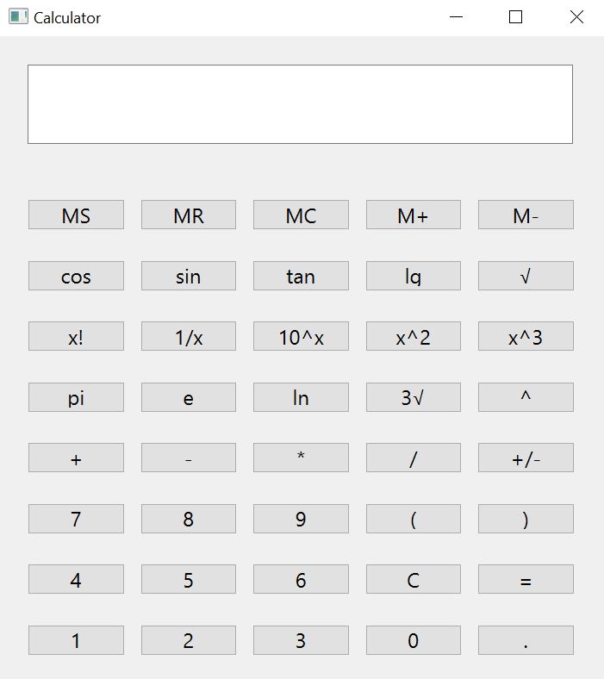

**Конторльні приклади для демонстрування роботи програми :**

$cos(60)$

$20*(6^{3}+7)$

$sin(32)$

$\sqrt[3]{42}$

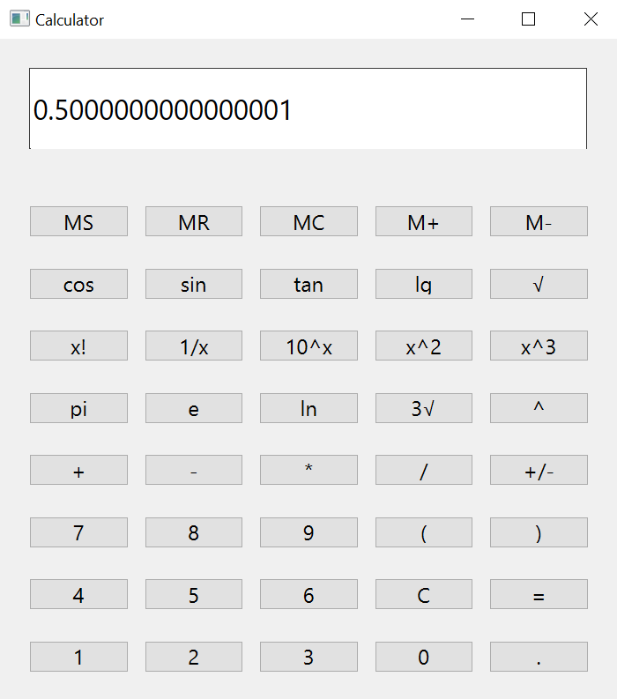

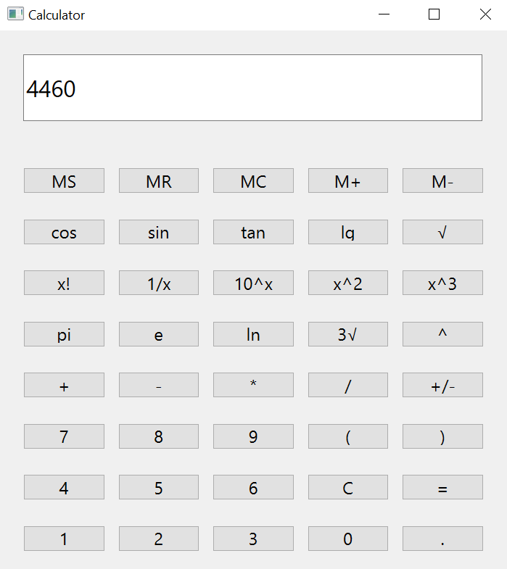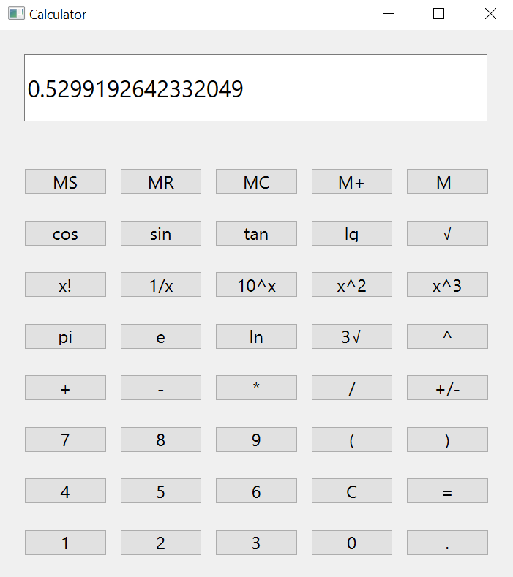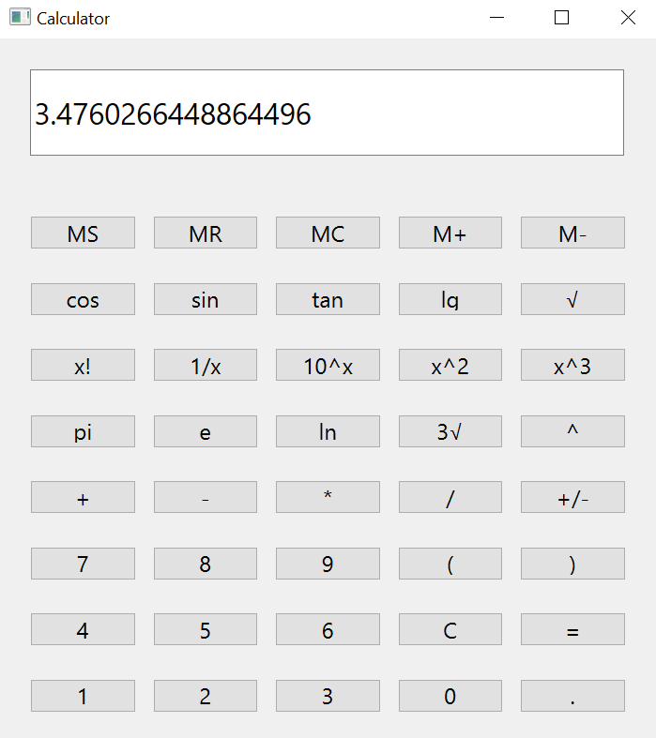

**Функції роботи з пам’яттю :**

1. **MS і MR :   
   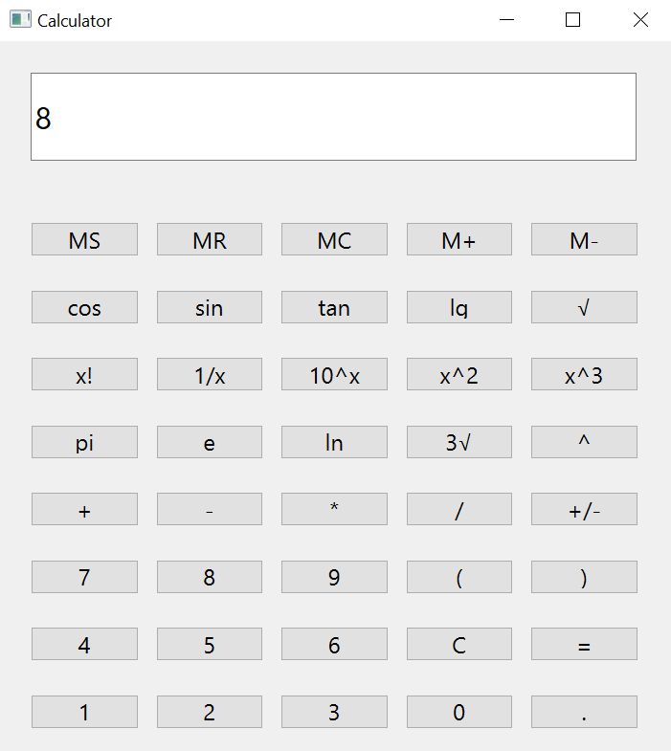**

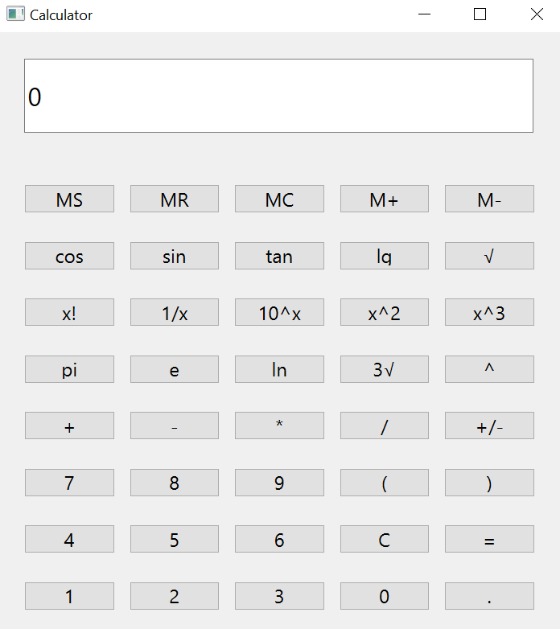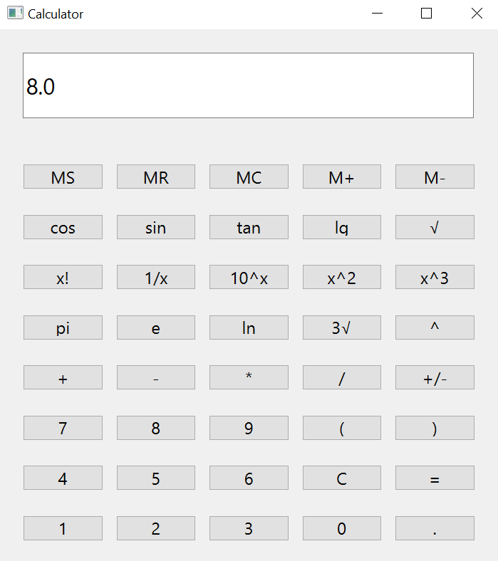

1. **Функції M+ і M- :** 